

6 September 2024

Dear Parents and Carers,
I would like to take this opportunity to welcome you all to St Matthew’s, whether you are returning after summer holidays or joining us for the first time this year. We have a lot of new families joining us this term and we look forward to working alongside you all to achieve the best possible Early Years education for your children. This year Mrs Collaki, a senior teaching assistant, will be assisting me in our newly formed EYFS Class. Ms Smith, a specialist in SEND support, will run intervention sessions to develop children’s PSED and Speech and Language skill on a one-to-one basis and in small groups. We will also have Mrs Mattuci, who will provide one-to-one support to the children with SEND.
Our main focus for the next few weeks will be settling the children into school routines, acquiring positive learning behaviours and building friendships.
Termly topics will be in the form of Big Questions. Our Autumn 1 Big Question is ‘Who am I? The big questions will allow a more open-ended approach to the topic, with learning activities largely based on the children’s interests.
Who am I?
Nursery Key Topic Skills | Reception Key Topic Skills
- I begin to develop confidence in speaking about myself, my family and my home  - I can name the members of my family  - I can say my name and how old I am  - I can say what I like and what I don’t like  - I can say how I feel  - I can learn a few simple action rhymes  - I know where things are in my Nursery classroom  - I can use my senses to explore things around me  - I can name common body parts  - I can show interest in numbers and counting through joining in with counting nursery rhymes.  - I begin to trace the letters of my name on my name card  - I begin to engage with mark-making activities | - I can speak about myself, my family and my home in full sentences.  - I can say what I like and what I don’t like, giving reasons  - I can say how I feel and show awareness how people around me and characters in stories/videos are feeling  - I can be a good role model for younger children  I can sing a few simple topic related Nursery rhymes and songs from memory  - I can name common body parts and say what they are used for.  - I can write my name on all my work  - I can tune into and identify the sounds of musical instruments, animal sounds and environmental sounds (Phase 1 Phonics)  - I can hear initial sounds in words (Phase 1 Phonics)  I can use the knowledge of learnt phonemes to write labels for my drawings  I can count at least 5 objects accurately.
Activities/Resources/Experiences | Vocabulary:
Weekly Circle times talking about, ourselves, our families, like dislikes, feelings and emotions  Self-portraits – drawing, painting and collage  Using senses in experiencing various textures. e.g. foam, toothpaste, playdough, sand, water, paint  Exploring the sounds of musical instruments  Tasting fruit and vegetables  Acting out stories and nursery rhymes  School Nurse Visit to talk about hand washing/brushing teeth | Family members: mum/mother, dad/father, grandmother, granddad/grandfather, brother, sister, aunt, uncle, cousin  Body parts: head, neck, stomach, chest, leg, arm, knee, foot/feet, toe, finer, thumb  Feelings: happy, sad, excited, silly, sick, angry, worried, feel  Routines: teacher, classroom, tidy up, playground, table chair, draw, write, trace, cut, stick, paint, sit, run, cross your legs, fold your arms, listen, look at me, wash your hands, share, take turns

Key Texts:
Each term we will have a set of key picture books which will be used as a stimulus for discussions, mark-making opportunities and cross-curricular learning. This term the suggested texts are:
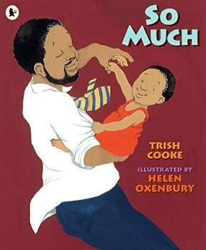
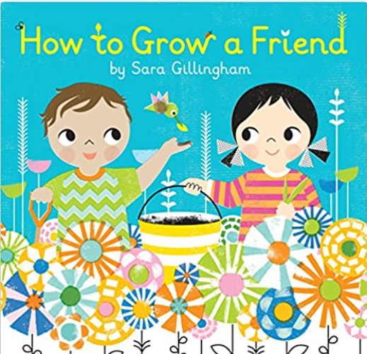
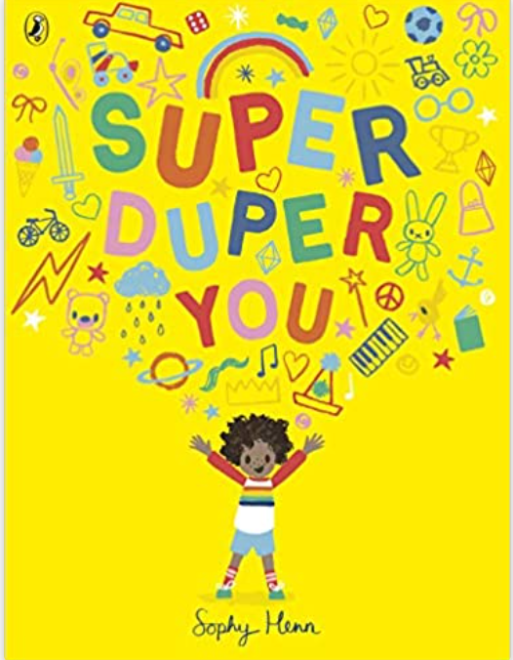
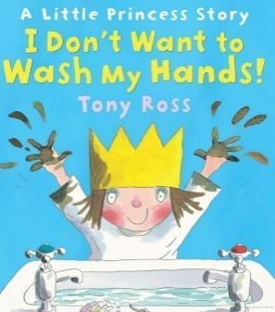
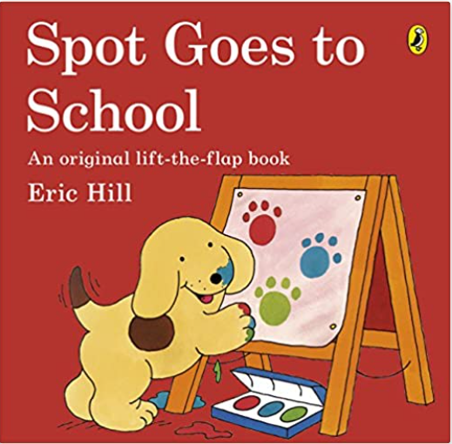
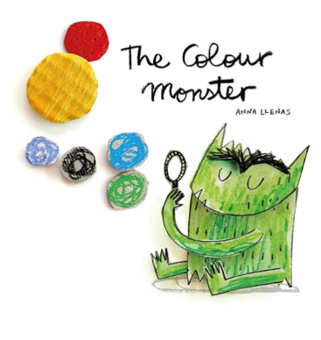
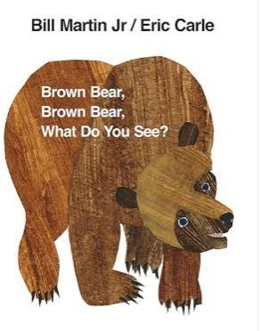
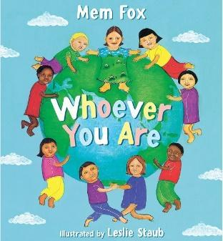
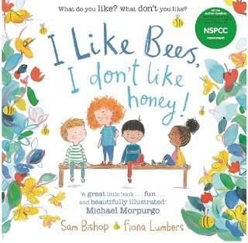

These are the books we plan to use; however these may change depending upon the interests and needs of our class.

In addition to the Parent Information pack on our school website, the following information will also be helpful as your child starts or continues their learning journey at St Matthew’s:
- School Uniform: All the children must come to school wearing the correct school uniform. Jogging bottoms are often a better choice for nursery children. Elasticated school uniform trousers are a sensible choice for Early Years children as they encourage developing independence. Trousers with a zip and a button should only be used if your child can fully manage them independently. Please ensure that all uniform items are named (especially sweatshirts and cardigans) as this helps to return lost items to the right children. It is important that the children wear appropriate footwear – comfortable black school shoes with Velcro fastenings help with developing independence. Shoes with shoelaces should not be worn to school at this point.
- Water Bottles: Please can you send your child to Nursery with a clearly labelled water bottle, which will be made accessible to them throughout the day.
- Book Bags: These are an important part of school life as they help to bring home books, letters or art work that the children have made. The book bags need to be brought to school every day. Please make sure your child’s name is clearly labelled on their book bag. Books will be changed on Mondays.
- Spare Clothes: Each child needs to have a set of spare clothes in a clearly labelled string draw bag, e.g. St Matthew’s PE bag, which will be kept on your child’s peg. Please note that our cupboard cannot fit bags of other styles due to a very limited space
- Snack Time: Fruit and milk will be made available to the children every day. We will encourage children to try all of the fruits that are provided. If you haven’t yet told the school office about any medical or allergy information about your child, please do pass this on as soon as possible.
- Tapestry: We use an online program called Tapestry to record your child’s learning journey through Early Years. Please see the attached letter with more information and a consent form that needs to be returned in hard copy to a member of the EY team so that your account can be set up. We value parents’ contributions towards the children’s learning journey. If you would like to share some great learning from home, you can also upload pictures and videos onto your child’s Tapestry online journal. Some of these will be shared with the rest of the class. If your Tapestry password needs resetting, please let me know.
- Weekend News/Magic Moments will take place on Monday during our Literacy lesson time. I am looking forward to encouraging all of the children to share any exciting news and achievements from home with their peers. Your child might choose to share something exciting that happened at the weekend, something that they made at home or something that they have achieved (e.g. first swimming lesson). Please feel free to send in photographs/objects to accompany their Magic Moment on Monday morning. This activity will develop skills of confident speaking, listening and asking questions. As a follow up, the children will be encouraged to engage in a mark-making/drawing/writing activity where they will be able to apply their drawing and phonics skills in a meaningful context.
- Mike the Monkey - our much-loved classroom pet will start going home again after the half term
- Safety: To ensure the safety of all pupils, the use of mobile phones and taking pictures of the children by parents is not permitted in our Early Years setting.
- Medicines: Only prescribed medicines in the prescription packaging may be administered at School and all the relevant paperwork must be completed by the parent/carer prior to any medication being administered. General medication (such as Calpol, cough medicine, eye drops) cannot be administered by any member of staff.
- Pre-loved items: If you would like to donate a preloved item in good condition to the Early Years, please speak to a member of staff first, as we have very limited space for resources. However, we always need small bits and bobs for creative work, e.g. buttons, very small boxes, ribbons and bottle tops. We would also appreciate pre-loved puzzles, cars, aeroplanes, plastic animals, construction sets and age appropriate picture books in good condition.
- Celebration Collective Worship: Our whole school Celebration Collective Worship takes place every Friday at 2:50pm; all parents are welcome to attend. The black playground gates on St Ann’s Lane are opened at 2.45pm so that parents can join us for this special collective worship in the school hall.

Finally, if you have any questions or concerns please don’t hesitate to talk to me at school at the end of the day, or make an appointment by emailing the school office.

Yours sincerely
Mrs Farida Swift
EYFS Class Teacher

